O‘ZBEKISTON RESPUBLIKASI QURILISH VAZIRLIGI TOSHKENT ARXITEKTURA – QURILISH INSTITUTI QURILISHNI BOSHQARISH FAKULTETI

“AXBOROT TEXNOLOGIYALARI” KAFEDRASI

**«QURILISHDA AXBOROT TEXNOLOGIYALARI»**

**fanidan**

2-HISOB GRAFIK ISHI

**MAVZU**: C++ dasturlash tilida masalalarni dasturini tuzish

**Bajardi:** . **Guruh: Tekshirdi:**

TOSHKENT – **2022**

**Reja**

**Nazariy qism**

**1 masala( izoh: masala sharti yoziladi) 2 masala(masala sharti yoziladi)**

**3 masala(masala sharti yoziladi) Xulosa**

**1. Butun sonlarga oid masalalar**



**Dastur kodi**

**#include <iostream>**

**#include <math.h>**

**using namespace std;**

**int main()**

**{**

**float a,x,y;**

**cout<<"x ni kiriting x=";**

**cin>>x;**

**cout<<"y ni kiriting y=";**

**cin>>y;**

**a=(1+x*x)*x+exp(x)/(2*pow(x,2)+5)-x/(y*cos(pow(x,3)));**

**cout<<"Result a="<<a;**

**return 0;**

**}**

**Dastur Natijasi:**

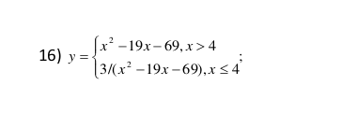

**Dastur kodi**

#include <iostream>

#include <math.h>

using namespace std;

int main()

{

float x,y;

cout<<"x ni kiriting x=";

cin>>x;

if(x>4){

y=pow(x,2)-19*x-69;

}

else{

y=3/(pow(x,2)-19*x-69);

}

cout<<"Result y="<<y;

return 0;

}

Dastur natijasi:

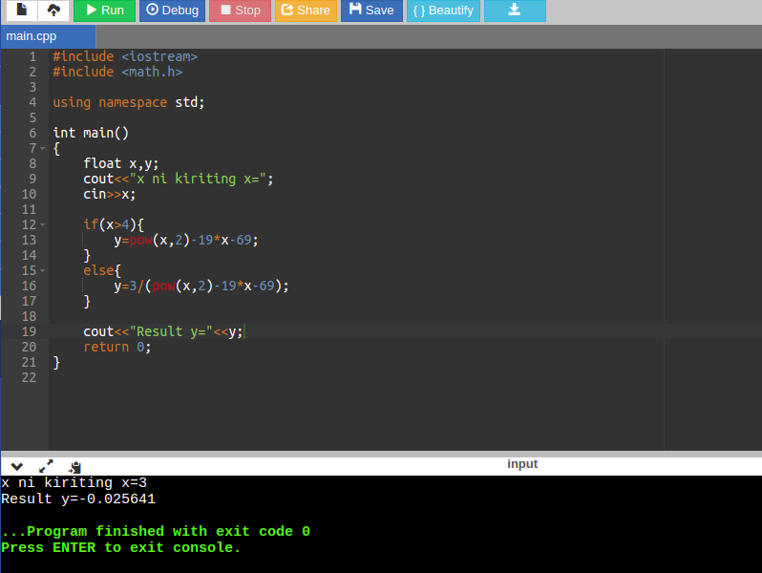

**3.Sikl operatoriga oid masalalar**

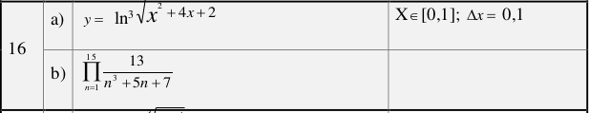

**Dastur kodi**

**#include <iostream>**

**#include <math.h>**

**using namespace std;**

**int main()**

**{**

**float y=0,P=1;**

**for (float x = 0; x <=1 ; x+=0.1) {**

**y=y+pow(log(pow(x,2)+4*x+2),3);**

**}**

**for (int n = 1; n <=15 ; n++) {**

**P=P*13/(pow(n,3)+5*n+7);**

**}**

**cout<<"Result 1 y="<<y<<endl;**

**cout<<"Result 2 P="<<P<<endl;**

**return 0;**

**}**

**Dastur Natijasi**

